High Mesa 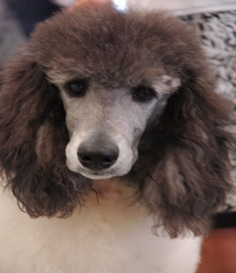 “PET/Companion” Puppy Contract
Contract and Bill of sale for companion/pet dog.
- Transfer of ownership from Seller
High Mesa Standards: Teresa Despres
6859 Church Rd, Olathe Colorado 81425. ph. 970-901-9672
Please complete below, as you wish the AKC registration to read
Buyers Full Name___________________________________Phone_________________
Address_____________________________________________
City/State____________________________________________Zip__________________
- Identification of Litter

sex___
Date whelped Breeder: High Mesa Standards litternumber ______________
Sire: Mr. Sinbad Rose AKA Bandit ___________________________________
AKC registration#PR19150901________________
Dam_Despres High Mesa Ocean Breeze_________________________________ AKC registration #PR19692306________________
- Health Guarantee
“Companion/pet, means that this dog is sold for that purpose only, and is not considered as breeding or show quality, unless otherwise stated within this contract.
- Dog is purebred. Pedigree is correct and given at the time of sale.
- Dog will be free of hereditary crippling defects visible by 12 months of age. If Found to be inflicted with any of the tested for degenerative diseases, refund for the amount buyer has already paid to seller for the dog will be made, provided dog is returned to seller, at the buyer’s expense.. This must happen within 7 days of discovery of such hereditary crippling defect.
- Seller will provide a 7 day health guarantee, starting the day the puppy is received. Puppy must be examined by a veterinarian within those 7 days. Through examination by a veterinarian acceptable to both parties, Should dog be found to be unsound at the time of examination, Seller will have the option to either provide a 100% refund of the amount that has been paid to seller for the dog, Or replace with another available dog, provided the dog is returned at buyers expense, within 7 days. Arrangements and cost of transportation are the responsibility solely of the buyer.
- For a period of 7 days, the puppy can be returned for a full refund for any reason other than injury, or health issues contracted while under the buyers care(if illness or injury is questioned by seller, it must be validated by an agreed upon veterinarian). Arrangements and any costs of transportation are the responsibility of the buyer
- If buyer ever must give up ownership of the dog, for whatever reason, at whatever age, said dog must be returned to the seller, at buyer’s expense, unless other arrangements are made between seller and buyer. In this case purchase price will not be refunded, and the dog will be rehomed.
NO OTHER WARRANTIES EXPRESSED, OR Implied
- Alteration Agreement: If you have not purchased full breeding rights, and it does not say so in your contract, you are obligated to spay/neuter your pet within its first year of life. Failure to do so will result in the dog being repossessed, by the original breeder, by court order, at the buyer’s expense.
We care for our dogs, and for the entire breed of the Standard Poodle. Because of our concern, we make this agreement to help prevent pet overpopulation, and the propagation of serious inherited faults. Train your dog well; give it the time it takes to raise a well-mannered, well rounded pet. It’s not the dogs fault if it doesn’t understand human. It is your job to teach, ensure exercise, and provide a healthy diet and environment. I encourage owners not to over immunize as we are finding that can be harmful. Don’t allow a vet to talk you into “doubling up “on a vaccine because you are behind. Better to be a little late with a vaccine, than early. Dog’s diets should consist mostly of protein in the form of meat. Not vegetable protein, low or no grain, and vegetables. Not sweets and people food. It is up to us to care for them correctly. Daily walking makes for a better dog. Keep your dog in a fenced area, a chain or rope is not acceptable. Dog’s love to be part of the family, Train them well so they are always welcome in the house!

If you have read and agree to all of these terms, please sign and date below
X________________________________________________________Date_____________

